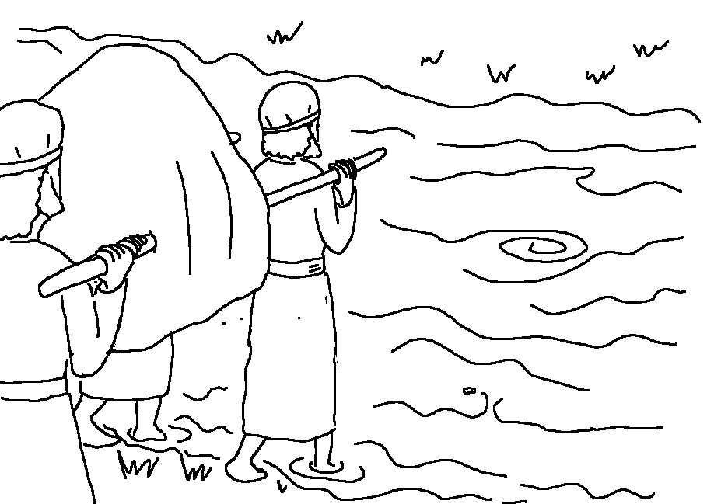

Have I not commanded you? Be strong and courageous. Do not be _ _ _ _ _ _; do not be discouraged, for the Lord your God will be with you _ _ _ _ _ _ _ _ you go.
Joshua 1:9_{NIV}

